Rubric SAR for M.Sc (Hons) degree Program of
DEPARTMENT OF SOIL & ENVIRONMENTAL SCIENCES
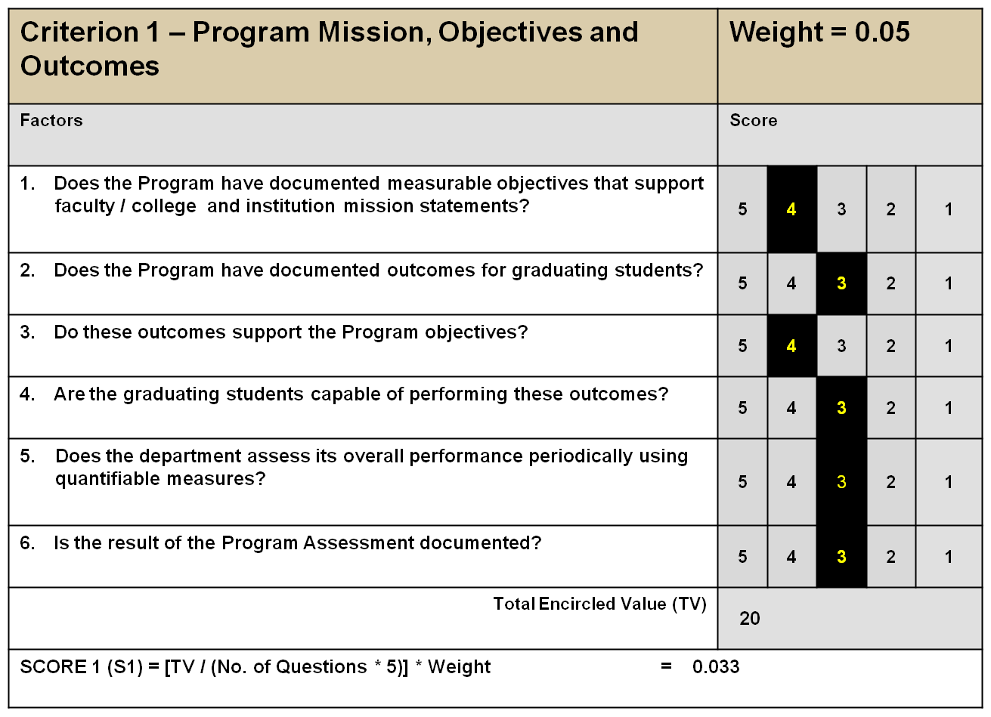
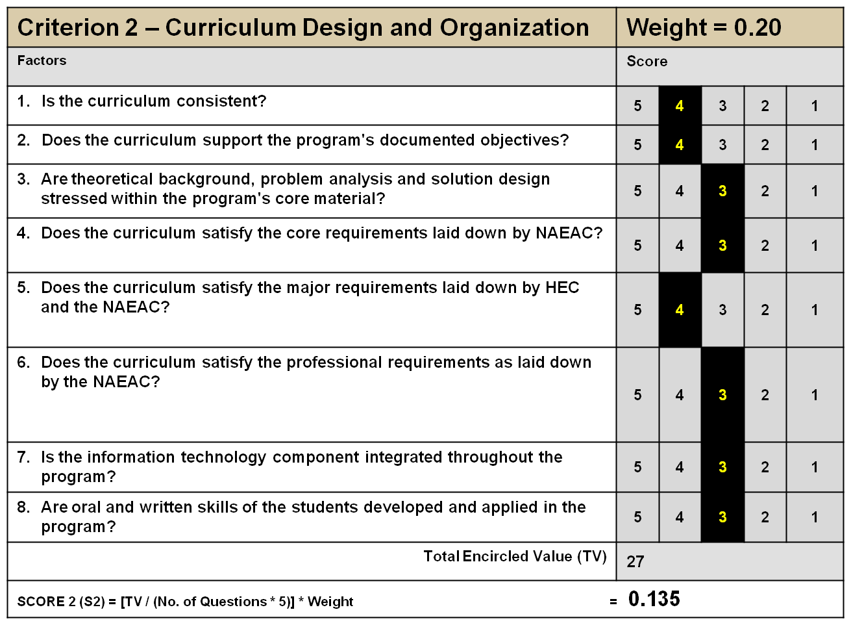

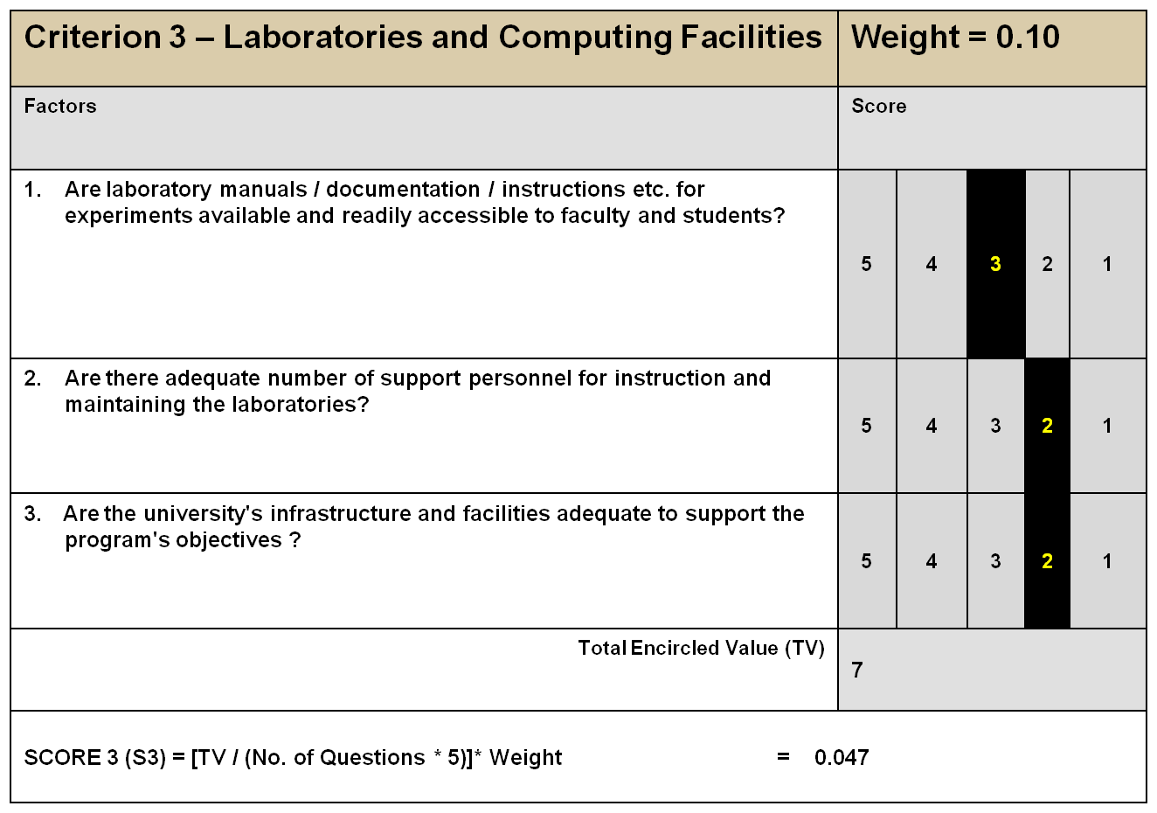
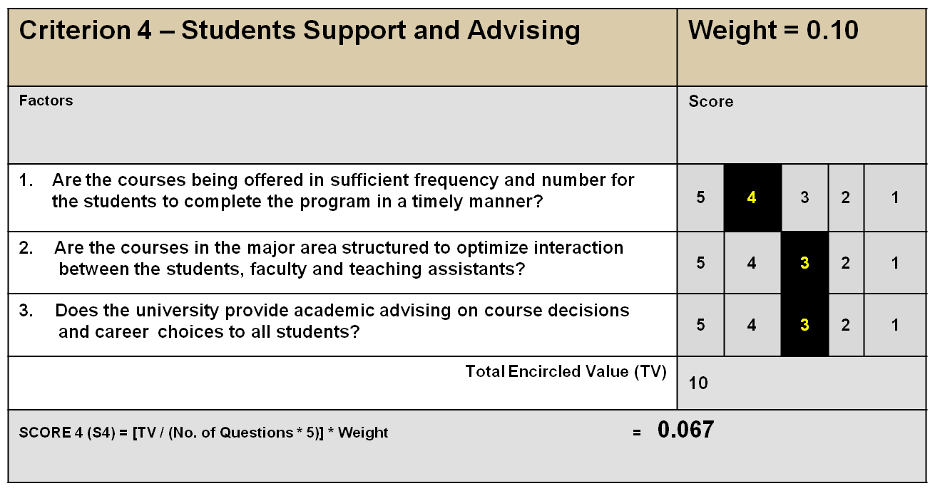

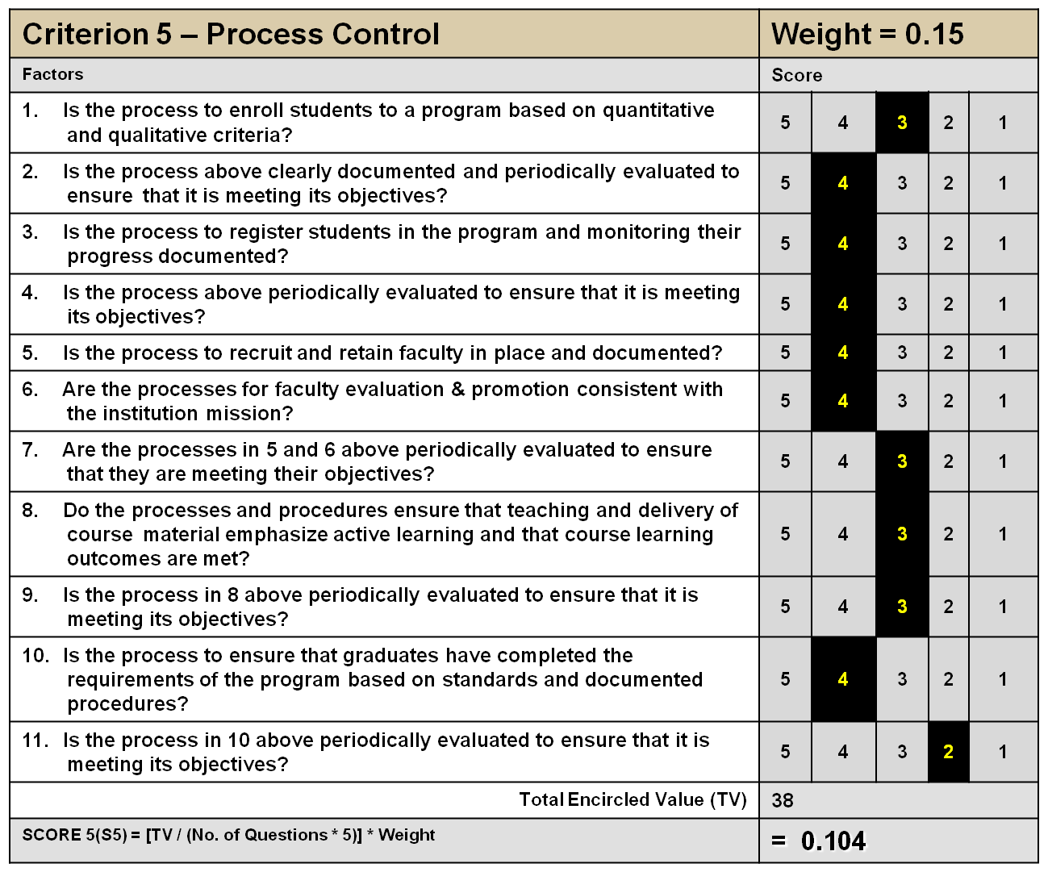

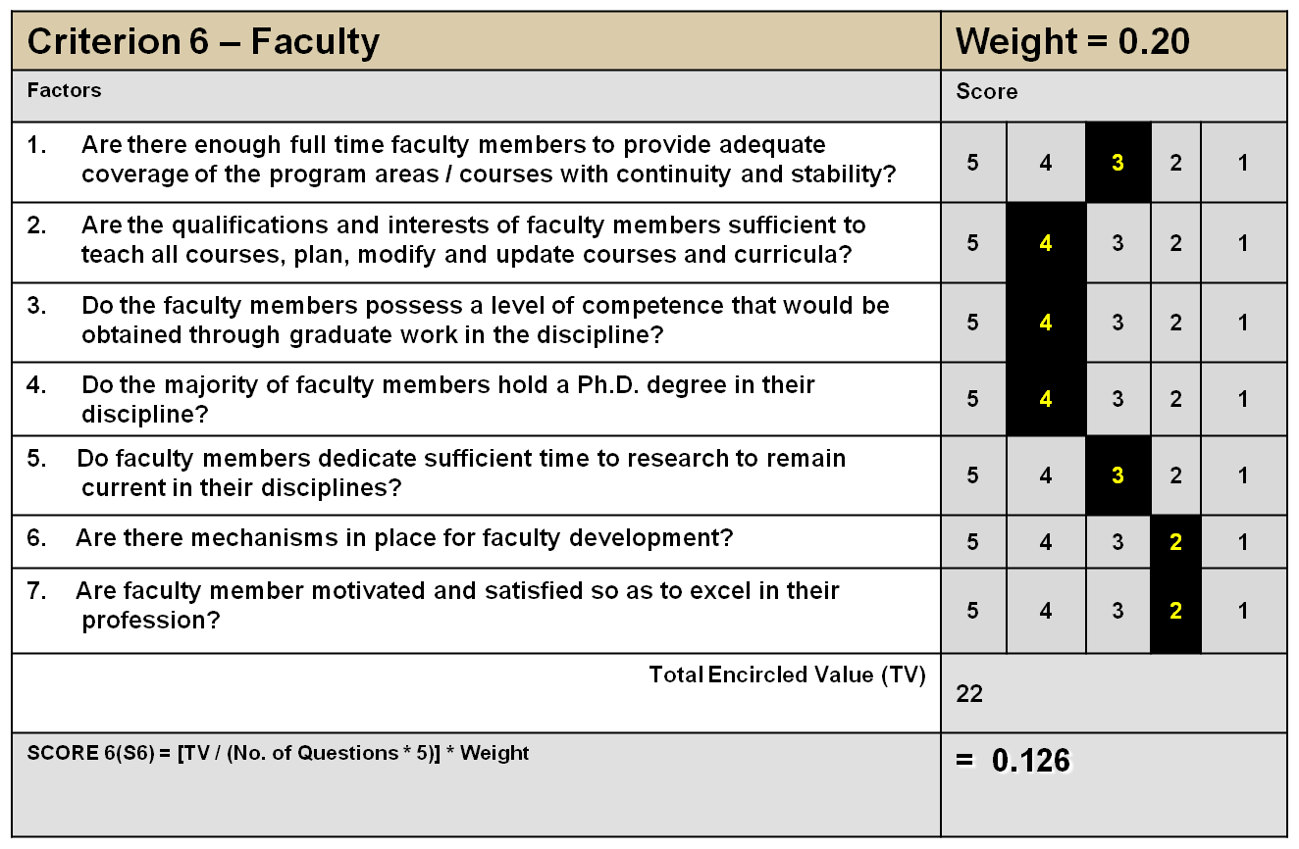

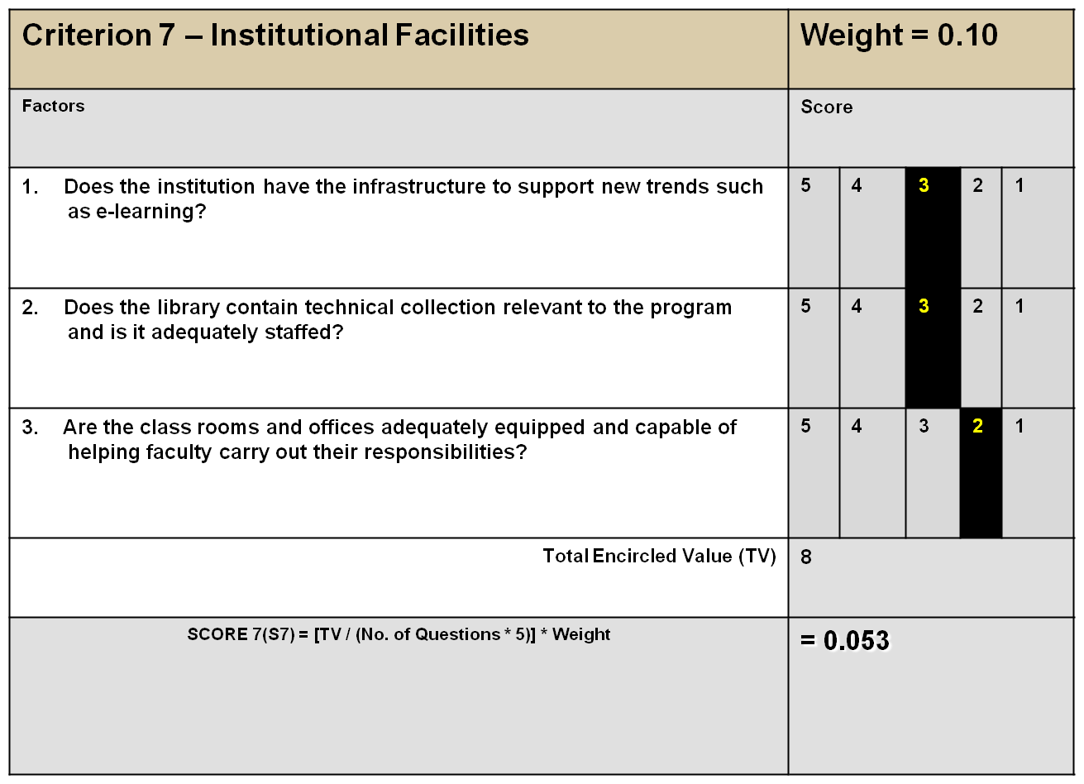
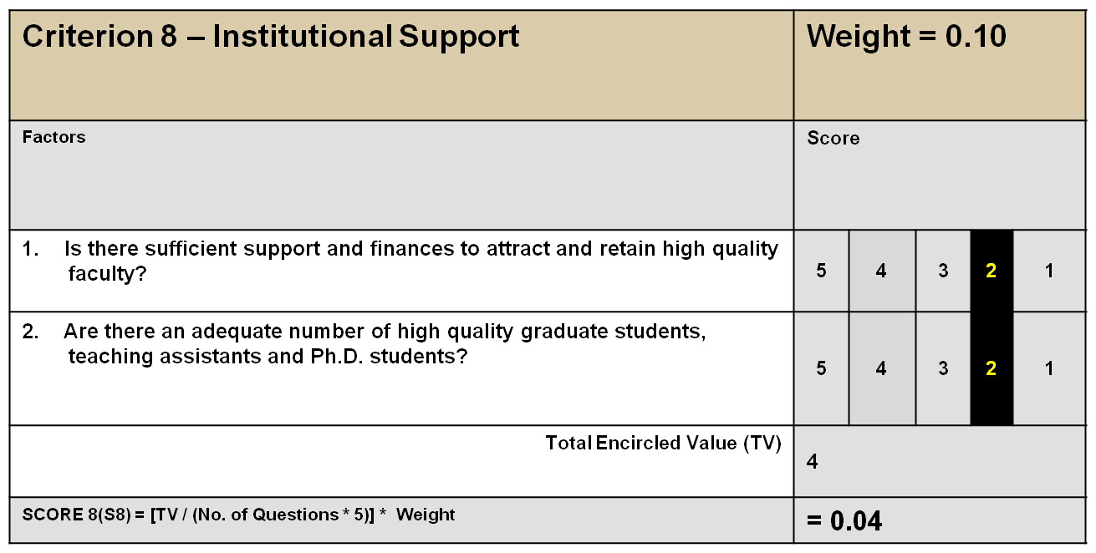

OVERALL ASSESSMENT SCORE:
S1 + S2 + S3 + S4 + S5 + S6 + S7 + S8 = 0.604

REMARKS:
- The department is doing well in most of the areas.
- The department has well qualified 12 faculty members and has basic infrastructure facilities.
- The department has four teaching and research laboratories which are fairly well equipped
with basic facilities.
- Students, faculty, employers and alumni were generally satisfied with the teaching and research programs at the department.

